**Index page:**

**In full screen:**

1. Unsymmetrical every right side - all pages have this problem everywhere of title next to content in a similar way.

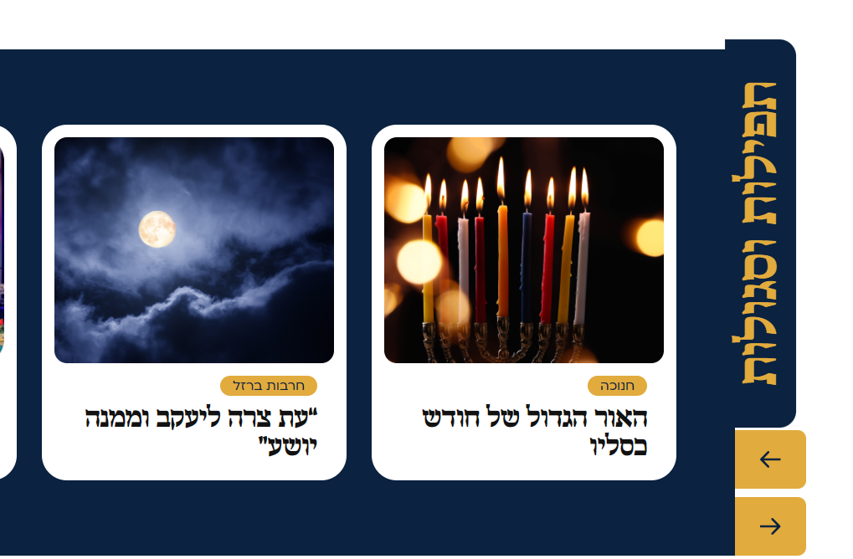

1. In some of the small sizes on the DESKTOP screen, the responsiveness does not seem correct so that the elements on the sides exceed the body of the page.
2. On a laptop screen (slightly smaller) - the elements overlap each other when scrolling the page



**Mobile screen:**

1. Title is too big, you can't see it



1. Subheadings are too big



1. The buttons should not float, and the times of the day and the advertisement on the left side should be removed
2. When you scroll to the sides with precious pearls and so on - it scrolls the whole screen together
3. In this section and others like it - all the texts and buttons are not coded according to the figma, and you need to be centered on the right side



1. Mobile does not have this part



1. The title "תפילות וסגולות" disappears, asymmetric buttons, as well as in mobiles, one whole cube will be shown according to the screen size, it is cut off..

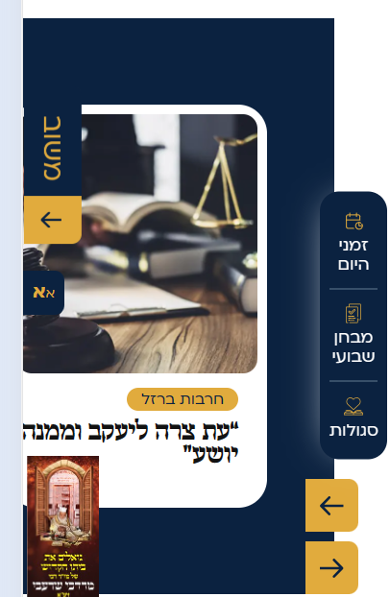

1. This part is designed in different colors and the button sizes are incorrect

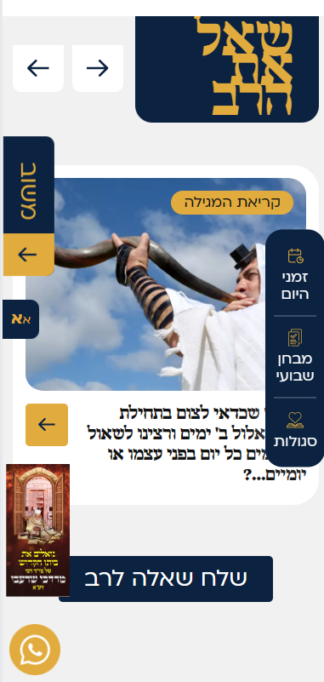

1. Each gallery should have an addition like there is in the transition in full screen

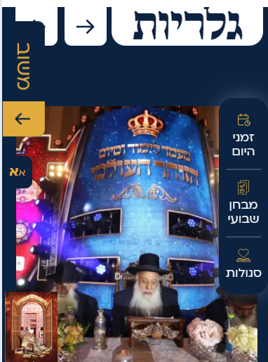

1. designed differently



1. Asymmetric button



1. A higher place for the message and a wider button, not accurate for figma

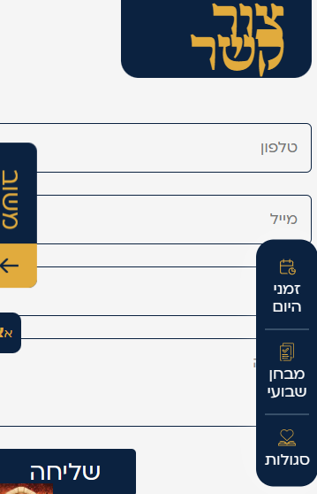

1. A smaller logo and all content should be divided into 2 columns and not one long column and mobile's FOOTER has a normal design for all texts without highlights

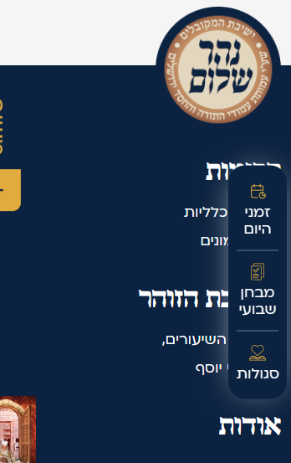

1. The size of the questionnaire panel should remain the same size, the size changes from screen to screen according to the content

